**Urban Recovery:**

A single player strategy board game

**Set Up:**

1. Place the Player Token (Purple Circle) on the purple circle
2. Place the Friend Token (Pink Circle) on the pink star
3. Place an Enemy token (Red Circle with arrow) on the purple circles with arrows so that the arrows line up
4. Place the bricks (green squares), cold tokens (blue circles) and enemy reference (tan/pink rectangle) to the side of the board

**Objective:** Navigate your way to the gang’s hideout, avoiding the sight of the enemies or dying from the cold, to rescue your friend and safely make it back to the start.

**Game Play:**

1. The Player and Enemies take turns moving
2. Player moves first
   1. Player can move up to 4 spaces, but is not required to move
   2. If the player is next to a green square (or circle) the player may pick up a brick (one brick can be held at a time) and place it into the held brick spot
   3. If the player is holding a brick, they can throw the brick up to 4 blocks away (does not count as movement, and does not end turn)
      1. If the brick lands within the pink or tan area of an enemy (shown by the enemy reference tile), the enemy will automatically move onto the spot of the brick – facing the direction they would when moving to the brick
         1. Place enemy on brick to represent that they had just moved
         2. The enemy will not move on their turn
      2. If the brick hits an enemy the enemy will be stunned, and the player can move past them (they can even move over the same spot) without being seen.
         1. Place brick on top of enemy, showing that they are stunned
         2. Enemy will be remained stunned for the players next turn.
      3. The player can also throw a brick through the window of the hideout providing another way into the apartment.
         1. Brick will be placed inside the apartment and if it lands within the tan or pink area of an enemy, the enemy will move to the brick as stated above.
   4. The player may not pass through solid black lines
   5. The player may not move into the sight of an enemy (pink area shown by enemy reference tile) – doing so is a game over
   6. Player may enter yellow or blue squares
      1. When the player enters a yellow square, all cold tokens are removed from the board
      2. The blue squares provide protection from the sight of the enemies
   7. If the player is next to the friend token, they can release their friend and add the token to the friend area at the top of the board
   8. If the player reaches the purple circle with the friend token, they win the game
3. End of players turn
   1. The player places a cold token onto the board
      1. If 8 cold tokens are picked up, the player loses the game
4. Enemies Turn
   1. If an enemy is on a brick (brick was thrown, and they moved during the players turn) they do not move.
      1. Remove the brick and place to the side of the board
   2. If an enemy is off their path, but there is no brick (they did not move during their previous turn) they return to the closest spot on their path.
   3. If an enemy has a brick on top of them, they do not move
      1. If they had just been hit with the brick, keep the brick there – they are still stunned
      2. If they were stunned on their previous turn, remove the brick – they are no longer stunned
   4. Every other enemy move 4 spaces along their route, shown by the arrows on their path (excludes the enemy in front of the gang hideout door who only moves by the sound of a brick)
   5. If during the movement of the enemy, the player lands within the pink area of the enemy, the player loses.

*NOTE* Enemies can see through windows and doorways (but only straight through the window or doorway) They cannot see through any solid black line, but they can see diagonally

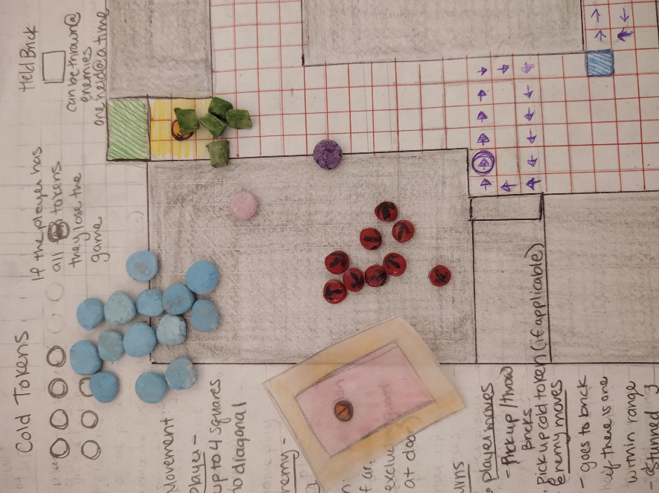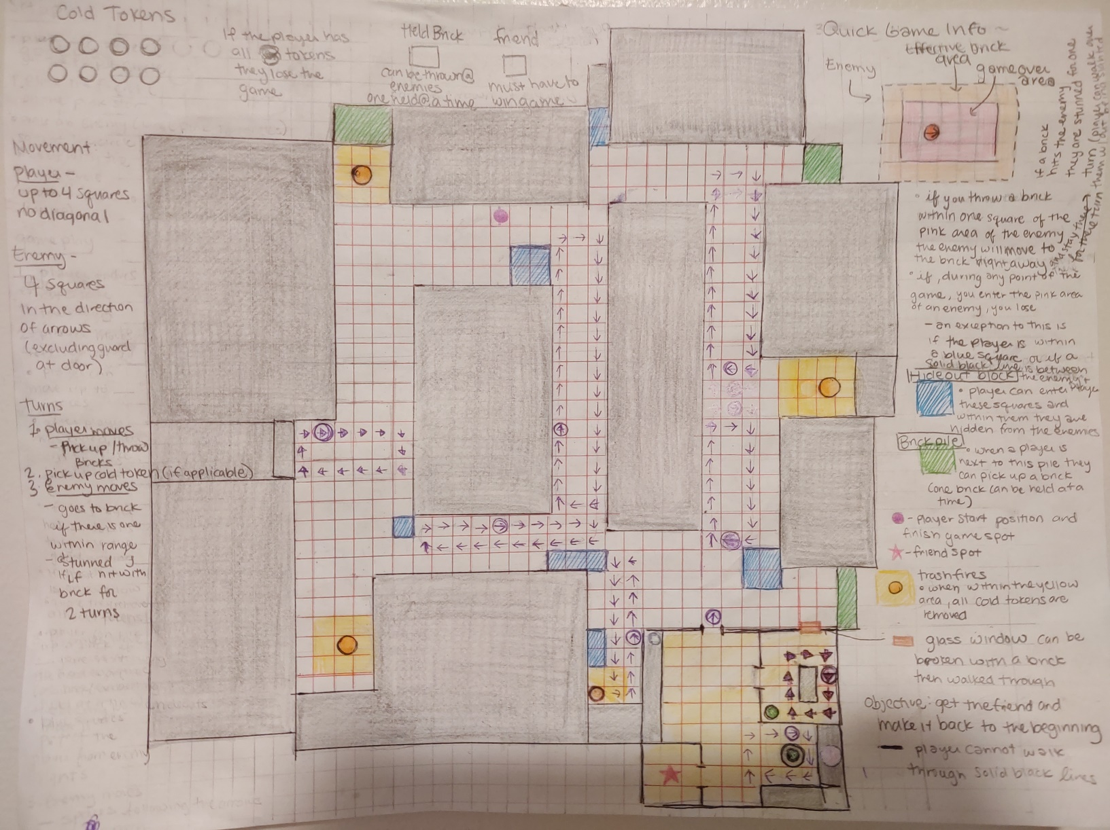

Above: a picture of the game board – the text is just a summary of the instructions

Left: a picture of the game pieces used